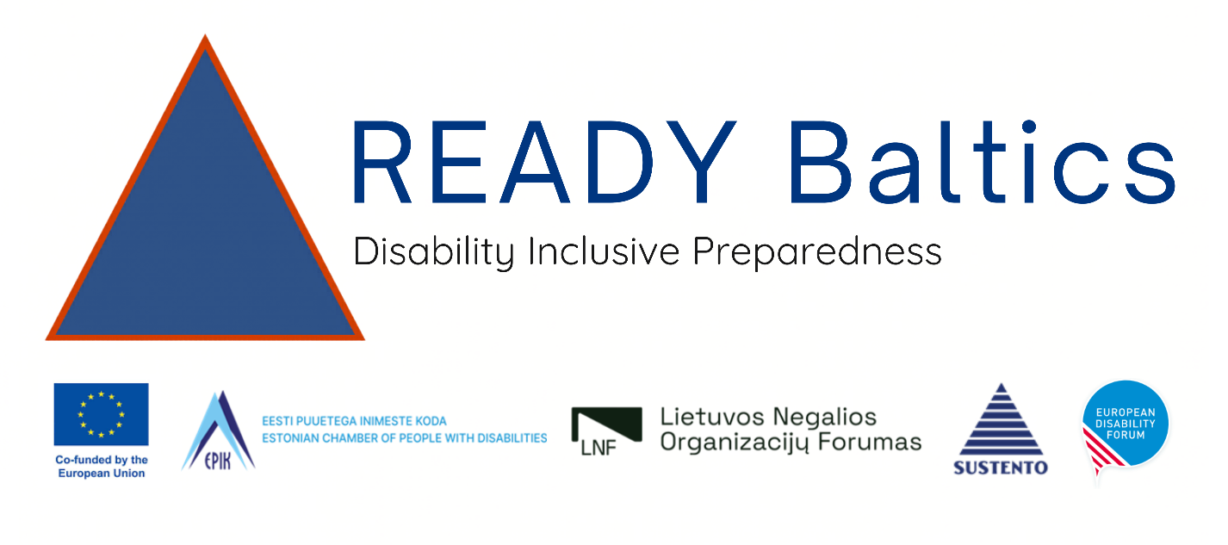

Estonian Forum of Persons with Disabilities

Advocacy brief for Estonia

Inclusive and Accessible Crisis Preparedness and Planning

Contents
Advocacy brief for Estonia 0
Inclusive and Accessible Crisis Preparedness and Planning 0
Advocacy brief for inclusive and accessible Crisis Preparedness and Planning 2
Situation Analysis. Framework and current situation 2
Global level 2
European level 2
Estonia: Current Situation 3
Crisis and National Defence Act 3
Mapping and geolocation 4
Crisis Information and Emergency Alerts 7
Accessibility of information 7
Accessible 112 8
Emergency Alerts and the Siren Network 9
Requirements for shelters 10
Evacuation and Rescue from Apartment Buildings 11
Participation of persons with disabilities and OPDs in crisis preparedness 12
Conclusion on Estonian context 15
Policy recommendations 17
Advocacy 18
Resources for better inclusion 18
Guidelines for persons with disabilities 18
Asks: EPIK’s Positions and Advocacy Priorities 18
About READY Baltics 20
Contact Us 20

Advocacy brief for inclusive and accessible Crisis Preparedness and Planning

Situation Analysis. Framework and current situation

Global level
The most important legal basis for involving persons with disabilities in crisis preparedness is the UN Convention on the Rights of Persons with Disabilities. Article 4(3) requires the state to closely consult with and actively involve persons with disabilities, through their representative organisations, in decision-making processes concerning them.
Article 11 requires the state to take all necessary measures to ensure the protection and safety of persons with disabilities in situations of risk, including armed conflict, humanitarian emergencies and natural disasters. These articles must be read together: disability-inclusive crisis preparedness is not limited to protecting and assisting persons with disabilities but also requires their active participation in preparedness planning and decision-making.
Global evidence points in the same direction. UNDRR’s 2023 survey received 6,342 responses from 132 countries. Among the respondents, 86% had not participated in community-level disaster risk reduction decision-making, although 57% said they would be willing to participate. Three quarters reported that no participation mechanism existed or that they were unaware of available participation processes.
The main barrier is therefore not a lack of willingness to participate, but a lack of accessible, institutionalised and inclusive pathways to participation.

European level
In a separate Europe-wide project, the European Disability Forum (EDF) examined disability-inclusive crisis preparedness in 38 countries.
Hundreds of policy documents were analysed, information was gathered from public authorities and organisations of persons with disabilities, and a consultation involving more than 60 participants was conducted. The study concluded that the inclusion of persons with disabilities across Europe remains uneven and fragmented.

Estonia: Current Situation
Estonian civil protection documents recognise that persons with disabilities may require additional assistance during a crisis and that different needs must be considered in evacuation procedures and crisis communication.

Crisis and National Defence Act
The Crisis Situation and National Defence Act contains some explicit provisions concerning persons with disabilities. It exempts persons with severe or profound disabilities from the performance of civic duties and also exempts caregivers of persons with disabilities while they are carrying out their caregiving responsibilities. The Act further requires public shelters and public sheltering locations to be accessible to everyone for the purpose of sheltering. However, this provision primarily establishes a general right of access and does not set out specific requirements for physical, sensory, cognitive or communication accessibility. Moreover, the obligation to adapt an existing building or part of it as a sheltering location applies only where this is feasible. Therefore, although the Act recognises persons with disabilities in certain contexts, it does not establish a comprehensive framework for ensuring their accessibility and assistance needs throughout emergency preparedness, sheltering, evacuation and response.
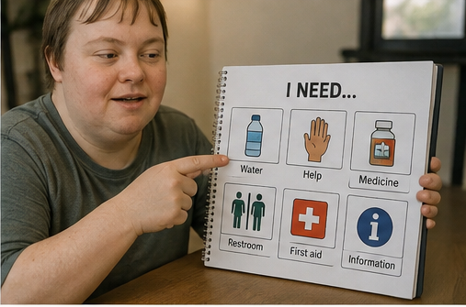

Mapping and geolocation
The 2018 Civil Protection Concept developed by the Civil Protection Task Force highlights the need for essential social assistance in crisis situations to be proactive. This requires identifying in advance the groups likely to need assistance, planning the necessary preparedness and resources, and establishing local information and assistance points to provide essential support.
The Civil Protection Framework document that persons with disabilities may be more dependent on assistance from others during a crisis and that their specific needs must be considered from the outset of crisis preparedness. According to the document, local authorities must know which people may require additional assistance during a crisis. It also recommends involving broader social networks in risk communication. The importance of addressing the needs of persons with disabilities has therefore been recognised at the national level, but the document does not assign organisations of persons with disabilities a defined role in crisis preparedness planning or decision-making.
A similar approach is evident in the Estonian 2024 Civil Protection Framework Document, which states that vulnerable groups must be considered when organising evacuations and that local authorities must be aware of both individuals and broader population groups who are unable to cope independently due to disability, age or social circumstances.
Mapping People Who May Require Additional Assistance
The Emergency Act remains in force until 30 September 2026. On 1 October 2026, it will be repealed and replaced by the Crisis Situation and National Defence Act (KORKS). Under KORKS a crisis is a formal legal status established by the Government when the statutory conditions are met or deemed to have arisen in the cases specified by law.
Crisis support points in Estonia where people can obtain water, electricity and other essential resources, as well as advice, information and assistance during disruptions to vital services, are known as resilience centres. No publicly accessible information is available on the accessibility of these centres. The accessibility of local authorities has been mapped on the My Municipality website.
A power outage lasting more than four hours may place a person who relies on home oxygen equipment, a ventilator, an electric wheelchair, hoist, bed or another electrically powered medical or assistive device in a life-threatening situation even before a crisis has been formally established. A person may also require different or additional assistance during a fire, evacuation or sheltering operation due to mobility, visual, hearing, communication, intellectual or psychosocial disabilities.
Local authorities currently lack a consistent, up-to-date and operationally usable overview of people whose lives, health or ability to live independently depend on electricity, assistance from another person, an assistive device, accessible information or disability-inclusive evacuation. Relevant information may exist in fragmented form across social welfare, healthcare or assistive-device systems, but it does not cover everyone and is not available to crisis-response officials in the necessary format or to the required extent.
A nationally standardised and secure information system should be established to identify persons who may require additional support during emergencies and coordinate the provision of assistance. The system should have a clear legal basis and a defined purpose, collect only the minimum information necessary concerning people’s functional assistance needs, and provide role-based and time-limited access solely for emergency preparedness and response.
Access to and changes made to the data should be logged, and clear responsibilities should be established for data accuracy, regular updating, retention and deletion. Individuals should have accessible means to register themselves and to review and correct their information, as well as to withdraw their consent where data processing is based on consent. Essential information must remain available during communications or power disruptions.
This approach would make it possible to:
- identify individuals and households whose lives or health could rapidly be endangered by an essential service disruption or another hazard;
- prepare an individual crisis assistance plan together with the person or household;
- define incident-specific response thresholds;
- contact the person or carer at an appropriate time;
- arrange backup power, such as a generator or access to a location with backup electricity, as well as welfare checks, transport, evacuation or other necessary assistance, and
- provide necessary information to the Emergency Response Centre, the Estonian Rescue Service Agency, emergency medical services or another authority responding to the incident.
The information collected must be based on the person’s actual assistance needs, rather than on their diagnosis, officially assessed degree of disability or receiving of social services. The solution must also include people who have not previously used local authority social services but might need help.

Problems Identified in Practice
The Estonian Rescue Service Agency has only a small number of staff who provide training on disability-specific considerations, including the characteristics of essential medical devices that require electricity, such as ventilators, suction devices and certain feeding pumps. Battery life varies considerably by device, settings, battery condition and use, and may be insufficient during a prolonged power outage.
Furthermore, because some devices operate using oxygen cylinders, several fires are known to have occurred due to incorrect use or because the device was placed in an environment that did not comply with fire safety requirements.
Home oxygen therapy presents specific fire-safety risks because oxygen supports combustion and increases the risk of ignition. Official patient guidance requires users to avoid smoking and open flames, maintain working smoke alarms and follow equipment safety requirements. Oxygen therapy nurses advise patients, organise home oxygen therapy, monitor patients’ health and treatment effectiveness and, where necessary, conduct home visits. However, publicly available guidance does not clearly define how fire or electrical hazards identified during such visits should be documented, referred to the competent authorities and followed up. According to an interview with the Taali Volunteer Rescue Brigade, cooperation between healthcare professionals and fire-safety specialists in assessing these risks is not yet systematically organised. A formal cooperation and referral protocol should therefore define the responsibilities of oxygen therapy services, healthcare providers, fire-safety specialists and local authorities.

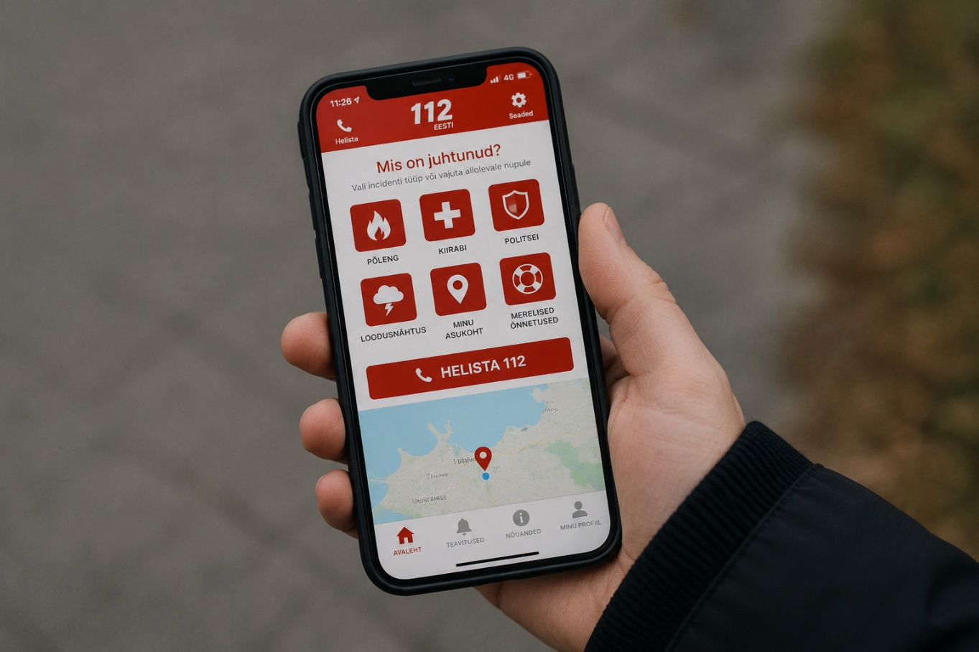

Crisis Information and Emergency Alerts

Accessibility of information
The Ministry of the Interior’s overview of civil protection states that the specific needs of vulnerable population groups must be considered when organising evacuations. The accessibility of services is also identified as an important priority for the Ministry.
Public press releases and information in mainstream media are generally not available in accessible formats, except for audio versions of some articles. The public is notified of emergency alerts by SMS.
For digital crisis information, the legal and technical basis for assessment is provided by the Consumer Protection and Technical Regulatory Authority’s digital accessibility requirements and the Public Information Act.
Public-sector websites and mobile applications must comply with the regulation on website and mobile application accessibility requirements and the publication of information describing accessibility. This includes ensuring that websites and applications can be used with assistive technologies. Website accessibility requirements also apply to the Ole Valmis website and application, crisis information portals and the civil protection e-learning environment. The results of the 2025 monitoring of the website provide further evidence that most public websites have accessibility issues.
Many public-sector bodies still fail to recognise the need to provide accessibility information in accessible formats, including directions to the premises and descriptions of the building’s accessibility features. Logos identifying accessible information are not used consistently in public awareness-raising. An exception is the Ministry of the Interior’s kriis.ee website, where, following a direct request from EPIK, easy-to-read information about the war in Ukraine was published in 2022.

E-learning
The civil protection e-learning environment published in May 2026 does not appear to provide clearly identifiable accessibility solutions, such as information in easy-to-read language, Estonian Sign Language, audio description, a separate audio version or other alternative formats.
National crisis preparedness information is available on the Ole Valmis website, but summaries of the information and instructions in easy-to-read are not provided. For example, information with audio on how to identify an attack drone was uploaded in June 2026, but it is not available in easy-to-read. Information in easy-to-read should be clearly signposted in the main menu, but this practice is not well established.
Although materials on Ole Valmis website are readable with a screen reader, the same information is not provided as a separate audio version. This is important, among others, for persons with psychosocial disabilities. In some materials more pictures, symbols and other visual aids would support the understanding of information and written texts.

Accessible 112
Work on making the 112-emergency service accessible is underway, but the new solutions have not yet been made available to users. According to the explanatory memorandum accompanying the draft legislation, extending the transition period would delay the introduction of additional life-saving communication channels by two years. The earlier plan of the Estonian Emergency Response Centre envisaged the introduction of real-time text communication by spring 2026 and new communication channels by summer 2027.
The draft legislation does not explain, for example, how communication in Estonian Sign Language will be ensured in emergency services. The national remote interpreting service does not currently provide round-the-clock interpreting from Estonian Sign Language into spoken Estonian. It is therefore essential to restore advanced-level training for sign language interpreters as soon as possible and establish a systematic 24/7 interpreting service.
The limited-vocabulary automated sign language translation robot being developed by the Institute of the Estonian Language may be suitable for pre-approved static information, such as general information at an evacuation centre, subject to testing with Estonian Sign Language users. However, it is not suitable for time-critical situations, context-specific communication, answering follow-up questions or exchanging individual-specific information.

Emergency Alerts and the Siren Network
In situations that can endanger the life and health of the people or the national security, the authority resolving the emergency (e.g. the police, the Rescue Board, the Health Board etc) is able to send an SMS to the people in the risk area. The sender of the message is EE-ALARM.
The siren network covers approximately 65% of Estonia’s population across 22 towns and settlements, as well as settlements in the vicinity of Tallinn. Although sirens are not activated without information also being disseminated through other EE-ALARM emergency alert channels, such as location-based SMS messages or app notifications, sirens may potentially be the first channel activated during a crisis.
By 2028, all operators of mass media channels, electronic communications services, public information screens and national mobile applications with at least 10,000 end users must join the EE-ALARM system. This is intended to ensure that important information reaches people quickly in the event of a potential threat.
The EPIK has received information that EE-ALARM notifications currently do not reach some older mobile phones with large buttons. The relevant authorities are aware of the problem, and the notifications are expected to reach these devices following updates soon.

Requirements for shelters
The field is regulated by Regulation No. 50: “Detailed List of Buildings Subject to the Obligation to Construct a Shelter, Requirements for Shelters and Sheltering Plans, Principles for Adapting Sheltering Places, and the Procedure for Preparing Sheltering Plans”.
On 1st of August 2026, the Building Code regulation “Requirements for Building Accessibility” entered into force. Although the regulation does not establish requirements specifically for shelters, it sets accessibility requirements for new and renovated apartment buildings and complements the shelter accessibility requirements set out in § 10 of the regulation on shelters.
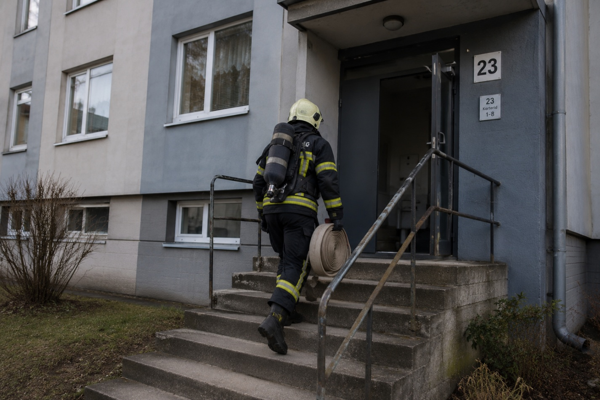
The regulation on shelters states that if a building is required to comply with accessibility requirements, the shelter located within that building must comply with those requirements as well. This includes ensuring access for persons with disabilities and people using mobility aids.
Although shelter requirements for new buildings entered into force on 1 July 2026, they apply only to larger buildings. A positive aspect is that the amendments also concern existing buildings: buildings that meet the relevant criteria must have a shelter plan in place by 1 July 2027 and, where feasible, a place of shelter must be established by 1 July 2028. For example, the City of Tallinn covers 70% of the costs incurred by apartment associations in establishing places of shelter.
In Estonia, crisis support points where people can obtain water, electricity and other essential resources, as well as advice, information and assistance during a crisis, are referred to as resilience centres. These centres are in buildings or premises belonging to local authorities or communities. However, no public information is available about the accessibility of these buildings.

Evacuation and Rescue from Apartment Buildings
A standardised International Symbol of Access (ISA) displayed on the exterior of an apartment building could provide first responders with an initial indication that someone in the building may require additional assistance during evacuation. As the sign does not identify a specific apartment or individual, its purpose is not to disclose a resident’s disability, but to alert first responders to a potential need for assistance.
The police currently receive information about persons with disabilities living in apartment buildings, based on the officially assessed degree of disability, but rescuers do not receive this information. A proposed solution is an agreement between the Estonian Rescue Service Agency and the Social Insurance Board that would enable data exchange, allowing rescuers to access relevant information about residents in time-critical situations.
In practice, rescuers use pictograms developed by the Estonian Rescue Service Agency and the NGO Vaimupuu in situations where a person, including an older person, is unable to understand or process information provided by rescuers. Voluntary rescue services also use pictograms depicting evacuation sites, transport points, evacuation areas and other relevant locations. Although pictograms are used in practice, not all pictograms currently in use are available on the Estonian Rescue Board’s website. The pictograms also need to be updated, as they lack explanatory text and standardised pictograms have not been agreed for every type of emergency.

Participation of persons with disabilities and OPDs in crisis preparedness
Policy framework and systemic participation gap
The Civil Protection Action Plan 2024–2027 addresses issues such as public warning, evacuation, sheltering, the capacity of local authorities and crisis communication. Its long-term evacuation objective also refers to “vulnerable population groups”.
However, the involvement of persons with disabilities and their representative organisations is not defined in the action plan as a separate activity, responsibility or indicator. This points to a gap in the organisation of meaningful and systematic participation and in recognising persons with disabilities as essential stakeholders.
The document establishes a basis for planning the necessary assistance, but it primarily treats persons with disabilities as recipients of assistance rather than as contributors to crisis preparedness, co-creators of solutions or participants in testing. For example, the document states that local authorities and the state must intervene when a person cannot provide for themselves or their family because of age, disability or specific social needs. To ensure support, local authorities must have the necessary information and the right to obtain data on vulnerable groups in their territory who are likely to need assistance during a crisis.
Early involvement of persons with disabilities is also supported by the Government Office’s Good Practice of Engagement. It requires government authorities to involve affected stakeholders when preparing decisions and to provide feedback on how their proposals have been considered.
Together with Article 4 (3) of the UN Convention on the Rights of Persons with Disabilities, this supports the principle that EPIKoda and other organisations of persons with disabilities must be involved from the stages of identifying the problem and developing solutions, rather than only being invited to comment on completed documents or materials.
The state has a practical model for co-creation. For example, the final report of the Government Office Accessibility Task Force, approved in 2021, treats accessibility as a principle that cuts across all policy areas. In addition to numerous government authorities and other organisations, EPIK participated in the work of the task force. A similar model of cooperation could be applied to the development of civil protection policy, crisis plans, exercises, training programmes and public information materials.
However, the document does not recognise OPDs as essential partners in implementation, monitoring or decision-making. The Ministry of Economic Affairs and Communications (MKM) coordinates monitoring through an Excel spreadsheet in which the responsible ministries report on their own actions, while state officials determine how progress is recorded and assessed. Consequently, despite EPIK’s participation in the task force, no permanent, publicly defined and adequately resourced participation mechanism has been identified.
The participation of persons with disabilities and OPDs has not been established as a distinct activity, responsibility or measurable objective in Estonia’s crisis preparedness framework.
Participation in practice
The participation of persons with disabilities and their representative organisations in developing crisis plans, training programmes, exercises and public warning solutions has not been defined as a clear activity, responsibility or measurable objective in Estonia.
Between 2022 and 2025, the Estonian Chamber of People with Disabilities submitted several written appeals to the Estonian Rescue Service Agency and met with various officials to share information about accessible formats and raise awareness, including of ways to improve the accessibility and usability of the website itself. In 2026, videos in Estonian Sign Language were added to Ole Valmis website crisis response guidelines, which is a very welcome development, but easy-to-read guidelines are still missing.
The Estonian Rescue Service Agency is currently preparing implementation guidance for shelters, but EPIK was not invited to participate in the relevant working group. EPIK submitted a written request to be involved to the Ministry of the Interior in November 2024. The working group included, for example, officials from the Ministry of Climate and the Consumer Protection and Technical Regulatory Authority, the latter of which performs state supervision in this field.
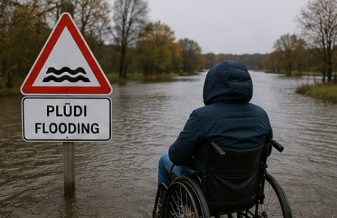However, the involvement of public authorities is not a substitute for the direct participation of persons with disabilities. Good policymaking requires the active involvement of the people who will be most affected by the solutions being developed. The UN Convention on the Rights of Persons with Disabilities also requires active participation of persons with disabilities in decision-making processes.
EPIK has pointed out that a machine-readable textual description of the visual appearance of the public shelter sign should be made available, enabling blind and partially sighted people to identify the sign using image recognition or similar
applications. Annex 2 to the Regulation contains a textual description of the
sign and is publicly accessible. Although the description is publicly available in Annex 2, representative organisations of persons with disabilities were neither informed of the Regulation’s adoption nor systematically involved in developing the related accessibility solutions.
The Social Insurance Board maintains an overview of the continuity and preparedness of care institutions for potential crises. It provides a self-assessment matrix developed in cooperation with the Ministry of Social Affairs, covering issues such as ensuring a reliable electricity supply. Although the aim was to strengthen cooperation with local authorities, private-sector service providers remain unclear about what support they can expect from national authorities or local governments.
The City of Tallinn has developed a plan for coordinating the evacuation of people receiving residential general care, special care and substitute care services. However, organisations of persons with disabilities were not meaningfully involved in the process. Information was passed from one official to EPIK and then disseminated further.
Private providers such as MindUp offer crisis preparedness, business continuity and risk management services, including crisis plans, shelter plans, resilience centre plans, training and exercises. Their publicly available service descriptions refer to access routes and support for vulnerable people but do not set out a systematic approach to disability accessibility, accessible communication, the participation of OPDs or the individual support needs of persons with different disabilities. Common disability-inclusive accessibility requirements should therefore also apply to crisis preparedness services and plans commissioned from private providers.
Cooperation to ensure an accessible 112 service has consisted of consultations between organisations of persons with disabilities and CGI Eesti OÜ, the company developing the information systems.
These examples show that cooperation has taken place, but it has mainly consisted of individual consultations, written proposals or involvement initiated by OPDs themselves. It has not developed into a permanent and adequately resourced participation mechanism covering policy design, implementation, testing, monitoring and evaluation.

Conclusion on Estonian context
Overall, the sources indicate that Estonian policy and legal documents recognise that persons with disabilities may have greater needs for assistance and accessibility during crises. However, the implementation of these principles is not sufficiently systematic: the responsible actors, budgets, deadlines, indicators and arrangements for public monitoring are largely undefined.
There is currently no operational system that would enable authorities responding to a crisis to take account of the needs of people whose lives, health or ability to live independently depend on electricity, personal assistance or accessible evacuation. Arrangements for providing backup power for electrically powered medical and assistive devices have likewise not been clearly defined. The accessibility of shelters, places of refuge, resilience centres and evacuation arrangements is inconsistent, while public information about their accessibility and the support available at these locations has not been standardised.
Public-sector websites do not consistently provide information in accessible formats on all essential matters concerning crisis preparedness, civil protection, national defence tasks and planning. Although some accessible materials, including videos in Estonian Sign Language, are available on the Ole Valmis! website, these formats are not consistently provided in the civil protection e-learning course or on other relevant public-sector websites. The Ole Valmis website also does not provide content that complies with Inclusion Europe’s easy-to-read guidance.
The participation of persons with disabilities in the development of crisis plans and services, exercises, training and the testing of solutions mainly takes place through individual consultations and initiatives. Persons with disabilities and their representative organisations are not yet consistently recognised as holders of crisis preparedness knowledge, planning partners, trainers, testers of solutions, volunteers or participants in decision-making processes. They continue to be treated primarily as a “vulnerable group” requiring assistance rather than as partners who actively contribute to crisis preparedness and possess valuable local knowledge.
A permanent participation mechanism with clearly defined responsibilities is therefore needed. Through this mechanism, persons with disabilities and their representative organisations should be able to participate in the design, implementation, testing, monitoring and evaluation of crisis plans, training programmes, exercises, public-warning systems, emergency services and digital solutions. Their participation must be continuous and adequately funded.
Civil protection information, including public press releases and information published in mainstream media, must be made available immediately in accessible formats, including, at a minimum, audio, easy-to-read language and Estonian Sign Language. Essential crisis information must be available in easy-to-read language and Estonian Sign Language, in subtitled videos, as audio content and in formats compatible with screen readers. Systematic cooperation should also be established with sign-language interpreting providers, such as Viipekeeletõlgid OÜ and the NGO Viipelism, as well as organisations specialising in easy-to-read language, to ensure that accessible information can be published without delay.

Policy recommendations
The meaningful participation of persons with disabilities and consideration of their knowledge and lived experience contribute to stronger solutions that perform more effectively in real-life situations. This strengthens crisis preparedness and resilience across society as a whole.
- Establish a permanent participation mechanism for persons with disabilities. Recognise persons with disabilities and their representative organisations as essential stakeholders and policy partners in all matters concerning civil protection and crisis preparedness. Organisations of persons with disabilities (OPDs) should have a clear and meaningful role in the design, implementation, testing, monitoring and evaluation of crisis plans, services, exercises and legislation. Their participation should be continuous, adequately funded and embedded in relevant decision-making processes.
- Recognise accessibility as an essential prerequisite for the quality, effectiveness and reliability of crisis preparedness. Accessibility must be ensured to strengthen preparedness across the entire population, including preparedness at the individual level.
- Ensure the accessibility of shelters, places of refuge and resilience centres and provide information in accessible formats.
- Establish minimum accessibility requirements for crisis information. Essential crisis information should be made available, at a minimum, in easy-to-read language, Estonian Sign Language, subtitled and audio formats, and formats compatible with screen readers. An accountability mechanism should specify who is responsible for assessing the accessibility of crisis communication, training materials and digital environments, and the criteria to be applied before their publication. Regular follow-up assessments should also be conducted, as the content of digital environments and training materials is continuously updated. The accessibility of civil protection training and information materials should be ensured consistently, including materials provided in English and Russian.
- Ensure an accessible 112 emergency service, including communication in Estonian Sign Language. OPDs should be involved in the design, development and user testing of new solutions before their implementation.
- Establish a local-level system for identifying and addressing individual assistance needs. The information collected should describe the practical support a person may require during a crisis, such as backup power, personal assistance, accessible transport or communication support.

Advocacy

Resources for better inclusion

Guidelines for persons with disabilities
The document “How to Act in Emergencies – Guidelines for Persons with Disabilities”, developed by the World Bank and the European Commission’s Directorate-General for European Civil Protection and Humanitarian Aid Operations (DG ECHO), was circulated for feedback among the members of the European Disability Forum and the wider European disability community, including the Estonian Chamber of People with Disabilities.
The presentation of the final draft took place in June 2026, but the guidelines have not yet been published. It is currently unclear how their translation and adaptation into sign language and easy-to-read formats will be organised.
This information must be made widely available in every country, as personal preparedness is one of the key elements of overall crisis preparedness.

Asks: EPIK’s Positions and Advocacy Priorities
- Persons with disabilities must not be regarded solely as a vulnerable group. They must be active participants in policymaking, as they are often among those most directly affected by the decisions taken.
- Organisations of persons with disabilities must have a meaningful role in crisis preparedness policymaking. This includes delivering training and participating in the development, review and implementation of legislation, guidelines and other solutions. Collaboration and co-creation must also include the testing of environments and services.
- Systemic shortcomings must be identified in cooperation with organisations of persons with disabilities and openly acknowledged. Estonia is working to improve the accessibility of crisis preparedness, and progress is evident. However, the involvement of persons with disabilities and their representative organisations is not yet consistent or systematic. We have met with various officials over the years, but individual meetings cannot replace a permanent participation mechanism.
- A family carer must not be the state’s default fallback plan. A family member acting as a carer may ensure continuity in communication, medication, mobility and daily support. However, crisis plans must also work when the carer or family member is unavailable or requires assistance themselves.

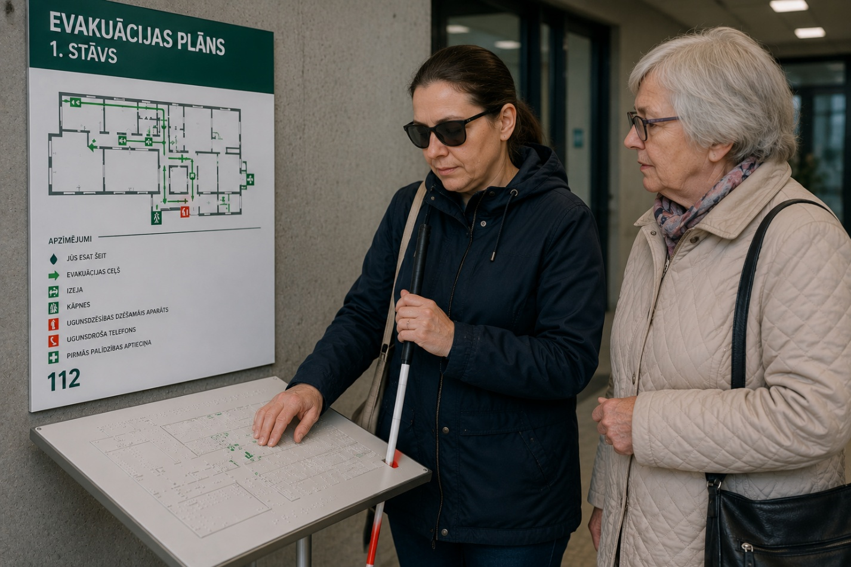

About READY Baltics
The READY Baltics EPIKoda project is a regional initiative strengthening disability-inclusive civil protection and disaster risk management (CP/DRM) in Estonia, Latvia, and Lithuania. The project recognises that inclusive preparedness is not a niche issue. It is a foundation for safer, more resilient societies for everyone.
Persons with disabilities are among the most affected during crises, facing higher mortality rates, inaccessible early warning systems, and exclusion from emergency planning. Despite strong international and European Union (EU) commitments, disability inclusion in preparedness and response remains uneven across Europe. READY BALTICS addresses this gap by turning policy commitments into practical systems, skills, and tools.
Resilience, Equity, Accessibility and DisabilitY inclusion through prevention and preparedness makes READY Baltics a new initiative READY to address gaps in current policies and practices!
READY MEANS EVERYONE!

Contact Us
https://epikoda.ee/
https://www.edf-feph.org/projects/ready-baltics/

Source interview 24.08.2026, Taali Volunteer Rescue Brigade
Ole Valmis URL: https://www.olevalmis.ee/en/how-to-recognize-an-attack-drone, accessed 26.08.2026
Source https://kriis.ee/en/preparing-possible-crisis/prepraring-possible-crisis-estonia/threat-alert, accessed 29.08.2026
Estonian Rescue Service Agency website, https://www.rescue.ee/et/ohuteavitus-ja-sireenivorgustik, accessed 25 August 2026
Source: Estonian Rescue Service Agency website. URL: https://www.rescue.ee/et/juhend/varjumine, accessed 25 August 2026.
Source: Delfi Media. URL: https://www.delfi.ee/artikkel/120382715/kriimud-generaatorid-ja-kommunikatsioon-kas-tallinn-on-kriisiks-valmis, accessed 25 August 2026.
Civil Protection Framework Document 2024, accessed 17 August 2026, p. 7.
Tuulik (Puuram), M. (2025): Public Policy and Spatial Design As a Collaborative Process On The Frontline of Governance
Source URL: https://www.mkm.ee/uudised/mkm-andis-ulevaate-ligipaasetavuse-rakkeruhma-soovituste-taitmise-seisust
08.05.2026. Regulation No. 50 of the Government of the Republic of 8 May 2026, “Detailed List of Buildings Subject to the Obligation to Construct a Shelter, Requirements for Shelters and Shelter Plans”, annex 2, https://www.riigiteataja.ee/aktilisa/1130/5202/6004/VV_08052026_m50lisa2.pdf
Social Insurance Board: https://sotsiaalkindlustusamet.ee/sotsiaaltoo-artiklid/hoolekandeasutuste-toimepidevuse-analuus
MindUp Systems, “Crisis preparedness, business continuity and risk management services”, accessed 29.08.2026: https://www.mindupsystems.com/teenused
Ministry of the Interior: Civil Protection, Source accessed on 17 August 2026 Estonian Rescue Board: What is Civil Protection? Source accessed on 17 August 2026 Government Office: National Defence Tasks and Planning. Source accessed on 17 August 2026

